SIMULATION OF NON-NEWTONIAM FLOW USING ANSYS

A PROJECT REPORT SUBMITTED IN THE PARTIAL FULFILLMENT
OF THE REQUIREMENT FOR THE DEGREE OF BACHELOR OF TECHNOLOGY
IN
CHEMICAL ENGINEERING
UNDER THE GUIDIANCE
OF
Dr. MALIK PARVEEZ
By
SHIVAM SAPOLIA (2017BCHE018)
AMOLDIP SINGH NARANG (2017BCHE053)
MANISH SAINI (2017BCHE055)



Department of Chemical Engineering

National Institute of Technology, Srinagar

CERTIFICATE

This is to certify that the thesis entitled, " SIMULATION OF NON-NEWTONIAM FLOW USING ANSYS" submitted by SHIVAM SAPOLIA, AMOLDIP SINGH NARANG, MANISH SAINI in partial fulfilments for the requirement for the award of Bachelor of Technology Degree in Chemical Engineering at National Institute of Technology, Srinagar is an authentic work carried out by him under supervision and guidance.
To best of my knowledge, the matter embodied in the thesis has not been submitted to any other University/Institution for the award of any Degree.

Date: - Dr. MALIK PARVEEZ
Department of Chemical Engineering
National Institute of Technology
Srinagar-190006

ACKNOWLEDGEMENT

I would like to convey my sincere gratitude to my project supervisor, Dr MALIK PARVEEZ for his invaluable suggestions, constructive criticism, motivation and guidance for carrying out related experiments and for preparing the associated reports and presentations. His encouragement towards the current topic helped me a lot in this project work which also created an area of interest for my professional career ahead.

I owe my thankfulness to Dr M.A RATHER , Head of the Department of Chemical Engineering for providing necessary facilities in the department and also to Dr MALIK PARVEEZ for the excellent coordination and arrangement towards the consistent evaluation of this project.

I thank my family and friends for their encouragement towards this project work.

Date:
Place: Shivam Sapolia (2017BCHE018)
Amoldip Singh Narang (2017BCHE053)
Manish Saini (2017BCHE055)
Department of Chemical Engineering
NIT, Srinagar-190006

CONTENTS
_{PAGE NO}.
Abstract ix
List of Tables vi
List of Figures v
List of Symbols vii

CHAPTER 1: Introduction 9

CHAPTER 2: Classification of Fluid Behavior
2.1 Definition of Non-Newtonian Fluid 11
2.1.1 Non-Newtonian Fluid Behavior 12
2.2 Time Independent Fluid Behavior 13
2.2.1 Shear Thinning Fluids 14
2.2.2 Power Law or Ostwald de Waele Equation 15
2.2.3 Visco-plastic Fluid Behavior 15
2.2.4 Shear-Thickening or Dilatant Behaviour 16
2.3 Time Dependent Fluid Behavior 17
2.3.1 Thixotropic Behaviour 18
2.3.2 Rheopectic Behaviour 19

CHAPTER 3: GENERAL EQUATIONS OF BEND
3.1 Dean Number 20
3.2Friction Factor 20

CHAPTER 4: CFD ANALYSIS
4.1 Mathematical Model 21
4.2 Measurement of Rheological properties 21
4.3 Governing Equations 22
4.4 Boundary conditions 23
4.5 Assumption of SCMC Solution flow through bends 23
4.6 CFD Procedure 23

CHAPTER 5: RESULT AND DISCUSSIONS
5.1 Numerical Simulation 25
5.2 90 Degree Bend Pipe 25
5.3 U Tube Bend Pipe 31
5.4 Discussion 38
5.4.1 Effect of bend angle on single-phase pressure drop 38
5.4.2 Effect of bend angle on velocity magnitude, velocity vector 38
5.4.3 Effect of bend angle on Reynolds number and dynamic
pressure 38
5.4.4 Effect of bend angle on wall shear stress and strain rates 38

CHAPTER 6: CONCLUSION 40

References 41-42

LIST OF FIGURES

Fig 1: Stress-strain plot for non-Newtonian fluids 10
Fig 2: Schematic representation of unidirectional shearing flow 11
Fig 3: STRESS COMPONENTS IN THREE-DIMENSIONAL FLOW 12
Fig 4: Qualitative flow curves for different types of non- Newtonian fluid 14
Fig 5: Qualitative shear stress-shear rate behaviour for thixotropic and rheopectic materials 18
Fig 6: (a) Geometry, (b) Mesh Design For 90 Degree Bend 27
Fig 7: Scaled Residuals V/S Iteration for 90 Degree Bend 27
Fig 8: Static Pressure Contour for 90 Degree Bend 28
Fig 9: Static Pressure V/S Position Graph for 90 Degree Bend 29
Fig 10: Turbulent Kinetic Energy V/S Position for 90 Degree Bend 29
Fig 11:Velocity V/S Position Graph 30
Fig 12: Velocity Vector for U Turn Bend 32
Fig 13:Velocity Streamline for U Turn Bend 33
Fig 14: Velocity Magnitude V/S Position for U Turn Bend 34
Fig 15: (a)Velocity Contour, (b) Geometry For U Turn Bend 34
Fig 16: Static Pressure V/S Position 35
Fig 17:(a)Scaled Residual V/S Position,(b) Pressure Volume Rendering 35
Fig 18: Pressure Contour for U Bend 36
Fig 19: (a) Pressure gradient contour 3, (b) Mesh design for U bend 37
Fig 20: Contour 1 Static pressure for U bend pipe 37

LIST OF TABLES

Table No. Title Page No.

NOMENCLATURE

K′ consistency index [Nsn′ /m2];
d diameter [m];
De Dean Number;
n′ flow behavior index;
f friction factor;
h frictional energy loss;
k friction coefficient;
L length [m];
P pressure [N /m2], [Pa] or [kPa];
R radius [m];
Re Reynolds Number;
u velocity [m/s];
Greek symbols
α angle [degree];
ρ density [kg /m3];
∆ drop;
ν kinematic viscosity [m2 /s];
τ shear stress [N /m2];
µ viscosity [Pa.s];
Subscripts
z axial direction;
θ angular direction;
bp bend pipe;
b bend;
cb curvature of bend
l liquid;
p pipe;
r radial direction;

ABSTRACT

Non-Newtonian pseudo plastic liquid flow through different types of 0.0127 m diameter pipe bends as well as straight pipe have been investigated experimentally to evaluate frictional pressure drop across the bends in laminar and water flow in turbulent condition. We have studied here the effect of flow rate, bend angle, fluid behavior on static pressure and pressure drop. A Computational Fluid Dynamics (CFD) based software is used to predict the static pressure, pressure drop, shear stress, shear strain, flow structure, friction factor, loss co- efficient inside the bends for Sodium Carboxy Methyl Cellulose (SCMC) solution as a non-Newtonian pseudo plastic fluids and water as a Newtonian fluid. Laminar Non-Newtonian pseudo plastic Power law model is used for SCMC solution to numerically solve the continuity and the momentum equations. The experimental data are compared with the CFD generated data and is well matched. The software predicted data may be used to solve any industrial problem and also to design various equipment.
Keywords: fluent, CFD, bends, non-Newtonian pseudo plastic fluid, power law model, pressure drop, flow structure

Chapter:1

- Introduction ^{[1]}:
Non-Newtonian pseudo plastic fluids flow through bends are more complicated compared to the simple straight pipe as the bends are associated with different curve geometry. Bends are mainly used in petroleum and Refinery, Pharmaceutical, Rubber, Paper Pulp and Food industries as piping components for fluid transfer and as heat transfer equipment in boiler, heat exchanger, distillation column, and aircrafts. The idea of circulating blood flow pattern is different types of curved and bend blood vessels in aorta will help the doctors to identify the human diseases. Since the bends are curved in nature, the fluids entering in the bend influence the combined centrifugal and viscous forces. We have considered Dean Number (De) to explain the flow phenomena inside the bends. The De plays a same role as Reynolds Number (Re) in a straight pipe. The velocity and pressure distribution inside the bends generate centrifugal and secondary flow which will transfer the denser fluid to the outer wall of the bend at a faster rate compared to the lighter fluid. The fluid will return to the inner wall side of the bend after collision with the outer wall. This creates a transverse pressure gradient in the form of kinetic energy and also pressure loss across the bend. The idea of fluid flow phenomena inside the pipe bends is important to design and analyse the fluid machinery. The prediction of pressure drop through bend is uncertain as the combined skin friction loss and loss due to changes in flow direction may explain the mechanism of flow phenomena inside the bends. CFD analysis of non-Newtonian pseudo plastic flow through bends is important as it may be used as a complement to an experiment and also to lower the time and experimental cost of equipment. It gives us the conceptual studies of new design, redesign, detailed product development, troubleshooting with the help of numerical techniques where mass, momentum, energy, species are involved. The only disadvantage of this analysis is that the requirement of computer memory cost. The literature available for non-Newtonian pseudo plastic liquid fluid flow through pipe bends are very less. So, the experimental and CFD analysis, both are required to predict the flow phenomena inside the bends.
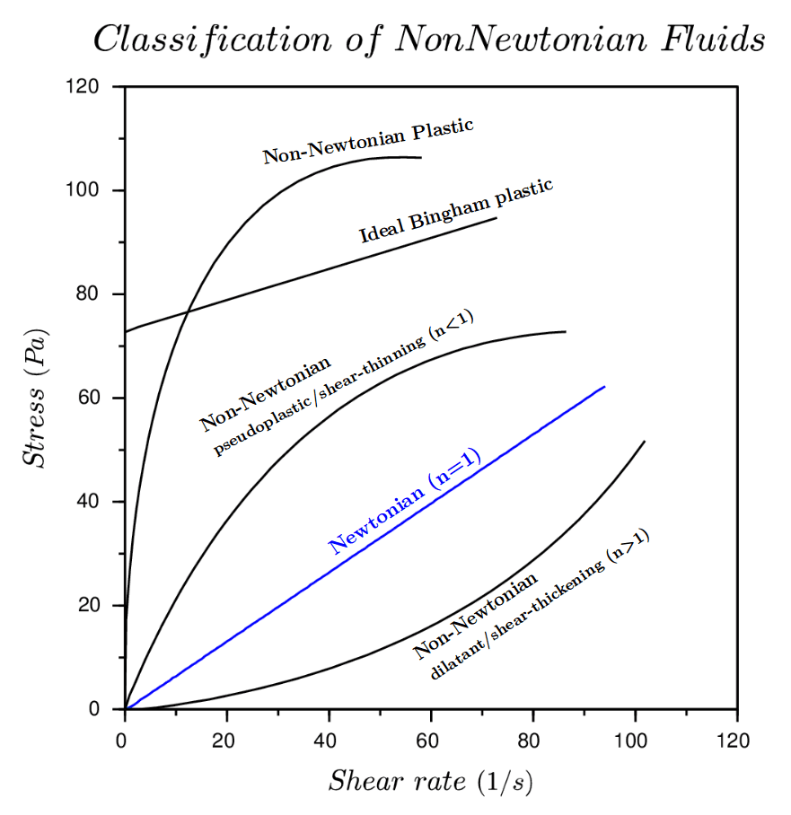

Fig 1: Stress-strain plot for non-Newtonian fluids

Chapter: 2

2.1 Classification of Fluid Behaviour
2.1.1 Definition of a Newtonian Fluid
In simple shear (Fig. 1), the response of a Newtonian fluid is characterized by a linear relationship between the applied shear stress and the rate of shear, i.e.,
σ_{yx} = F/A = ηγyx (1)
Fig. 1 and equation (1), represent the simplest case wherein there is only one non-zero component of velocity, Vx, which is a function of y. For the general case of three-dimensional flow (Fig. 2), clearly there are six shearing and three normal components of the stress tensor, S. It is customary to split the total stress into an isotropic part (pressure) and a deviatoric part as
S = −pI+σ (2)
Fig 2: Schematic representation of unidirectional shearing flow
Where σ is traceless, i.e., tr · s = 0, and pressure is consistent with the continuity equation. The trace free requirement together with the physical requirement of symmetry s = s T imply that there are only three independent shear components (off-diagonal elements) and two normal stress differences (diagonal elements) of the deviatoric stress. Thus, in Cartesian coordinates, these are s_{xy}(= s_{yx}),s_{xz}(= s_{zx}),s_{yz}(= s_{zy}) and the two normal stress differences defined as
Primary normal stress difference,
N₁ = s_{xx} −s_{yy} (3)
Secondary normal stress difference,
N₂ = s_{zz} −s_{yy} (4)
For Newtonian fluids, these components are related linearly to the rate of deformation tensor components via the scalar viscosity. For instance, the three-stress com ponents acting on the x face (oriented normal to the x axis) in Fig. 3 are written as follows
— −
$σ_{xx}=-2η_{\frac{∂v_{x}}{∂x}}$ (5)
$σ_{xy}=-η\left(\frac{∂v_{x}}{∂y}+\frac{∂v_{y}}{∂x}\right)$ (6)
$σ_{xz}=-η\left(\frac{∂v_{x}}{∂z}+\frac{∂v_{z}}{∂x}\right)$ (7)

Similar sets of equations can be set up for the stress components relevant to the y− and z planes. For a Newtonian fluid, in simple shear, s_{xx} = s_{yy} = s_{zz} = 0, because V_{x} only varies in the y direction. Thus, the complete definition of a Newtonian fluid requires it to satisfy the complete Navier-Stokes’s equations rather than simply exhibiting a constant value of shear viscosity.
−
−

Fig 3: STRESS COMPONENTS IN THREE-DIMENSIONAL FLOW

2.1.2 Non-Newtonian Fluid Behavior
The simplest possible deviation from the Newtonian fluid behavior occurs when the simple shear data σ/ γ˙ does not pass through the origin and/ or does not result into a linear relationship between σ and γ˙. Conversely, the apparent viscosity, de- fined as σ/γ˙, is not constant and is a function of σ or γ˙. Indeed, under appropriate circumstances, the apparent viscosity of certain materials is not only a function of flow conditions (geometry, rate of shear, etc.), but it also depends on the kinematic history of the fluid element under consideration. It is convenient, though arbitrary to group such materials into the following three categories:
−
- Systems for which the value of γ˙ at a point within the fluid is determined only by the current value of s at that point; these substances are variously known as purely viscous, inelastic, time-independent or generalized Newtonian fluids
- Systems for which the relation between σ and γ˙ shows further dependence on the duration of shearing and kinematic history; these are called time-dependent fluids
- Systems which exhibit a blend of viscous fluid behavior and of elastic solid-like behavior. For instance, this class of materials shows partial elastic recovery, recoil, creep, etc. Accordingly, these are called visco-elastic fluids
The aforementioned classification scheme is quite arbitrary, convenient, because most real materials often display a combination of two or even all these types of features under appropriate circumstances. For instance, a polymer melt to show time-independent (shear-thinning) and visco-elastic behavior simultaneously and for a china clay suspension to exhibit a combination of time-independent (shear-thinning or shear-thickening) and time-dependent (thixotropic) features at certain concentrations and /or at appropriate shear rates.

2.2 Time-Independent Fluid Behaviour
In simple unidirectional shear, this sub-set of fluids is characterized by the fact that the current value of the rate of shear at a point in the fluid is deter- mined only by the corresponding current value of the shear stress and vice versa. Conversely, one can say that such fluids have no memory of their past history. Thus, their steady shear behavior may be described by a relation of the form,
Depending upon the form of equation (8) three possibilities exist:
- Shear- thinning or pseudoplastic behavior
- Visco-plastic behavior with or without shear-thinning behavior
- Shear- thickening or dilatant behavior.
Fig. 3 shows qualitatively the flow curves (also called rheograms) on linear coordinates for the above- noted three categories of fluid behavior; the linear relation typical of Newtonian fluids is also included in Fig. 3.

Fig 4: Qualitative flow curves for different types of non- Newtonian fluid
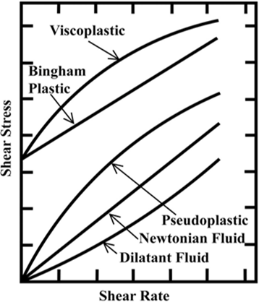

2.2.1 Shear Thinning Fluids
This is perhaps the most widely encountered type of time-independent non-Newtonian fluid behavior in engineering practice. It is characterized by an apparent viscosity η (defined as σ_{yx}/γ_{yx}) which gradually decreases with increasing shear rate. In polymeric systems (melts and solutions), at low shear rates, the apparent viscosity approaches a Newtonian plateau where the viscosity is independent of shear rate (zero shear viscosity, η₀ ).
$\lim_{{\dot{γ}}_{y_{x}}→0}\frac{σyx}{{\dot{γ}}_{yx}}=0$
Furthermore, only polymer solutions also exhibit a similar plateau at very high shear rates (infinite shear viscosity, η$∞$), i.e.,
$\lim_{γ_{yx}→∞}\frac{σ_{yx}}{{\dot{γ}}_{yx}}=η_{∞}$
In most cases, the value of $η_{∞}$ is only slightly higher than the solvent viscosity η_{s}. this behavior in a polymer solution embracing the full spectrum of values going from η₀ to $η_{∞}$. Obviously, the infinite-shear limit is not seen for polymer melts and blends, or foams or emulsions or suspensions. Thus, the apparent viscosity of a pseudoplastic substance decreases with the increasing shear rate, as shown in Fig. 6 for three polymer solutions where not only the values of η₀ are seen to be different in each case, but the rate of decrease of viscosity with shear rate is also seen to vary from one system to another as well as with the shear rate interval considered. Lastly, the value of shear rate marking the onset of shear-thinning is influenced by several factors such as the nature and concentration of polymer, the nature of solvent, etc for polymer solutions and particle size shape, concentration of solids in suspensions, for instance. Therefore, it is impossible to suggest valid generalizations, but many polymeric systems exhibit the zero-shear viscosity region below γ˙ < 10−2 s−1. Usually, the zero-shear viscosity region expands as the molecular weight of polymer falls, or its molecular weight distribution becomes narrower, or as the concentration of polymer in the solution is reduced.

2.2.2 Power Law or Ostwald de Waele Equation
the relationship between shear stress (σ )−shear rate(γ˙) plotted on log-log
co-ordinates for a shear-thinning fluid can be approximated by a straight line over an interval of shear rate, i.e.,
$σ=m{\left(\dot{γ}\right)}^{n}$
or, in terms of the apparent viscosity,
$η=m{\left(\dot{γ}\right)}^{n-1}$
Obviously, 0 < n < 1 will yield (dη/dγ˙) < 0, i.e., shear-thinning behaviour fluids
are characterized by a value of n (power-law index) smaller than unity. Many polymer melts and solutions exhibit the value of n in the range 0.3-0.7 depending upon the concentration and molecular weight of the polymer, etc. Even smaller values of power-law index (n ∼ 0.1−0.15) are encountered with fine particle suspensions like kaolin-in-water, bentonite-in-water, etc. Naturally, smaller is the value of n, more shear-thinning is the material. The other constant, m, (consistency index) is a measure of the consistency of the substance. Although, eq. (12) or (13) offers the simplest approximation of shear-thinning behaviour, it predicts neither the upper nor the lower Newtonian plateaus in the limits of g˙ → 0 or g˙ → ¥. Besides, the values of m and n are reasonably constant only over a narrow interval of shear rate range whence one needs to know a priori the likely range of shear rate to be encountered in an envisaged application.

2.2.3 Visco-plastic Fluid Behavior
This type of non-Newtonian fluid behavior is characterized by the existence of a
threshold stress (called yield stress or apparent yield stress, σ₀) which must be exceeded for the fluid to deform (shear) or flow. Conversely, such a substance will behave like an elastic solid (or flow en masse like a rigid body) when the externally applied stress is less than the yield stress, σ₀. Of course, once the magnitude of the external yield stress exceeds the value of σ₀, the fluid may exhibit Newtonian behaviour (constant value of η) or shear-thinning characteristics, i.e., η(γ˙). It therefore stands to reason that, in the absence of surface tension effects, such a material will not level out under gravity to form an absolutely flat free surface. Quantitatively this type of behavior can be hypothesized as follows: such a substance at rest
consists of three-dimensional structures of sufficient rigidity to resist any external stress less than ǀσǀ and therefore offers an enormous resistance to flow, albeit it still might deform elastically. For stress levels above ǀσ₀ǀ however, the structure breaks down and the substance behaves like a viscous material. In some cases, the build-up and breakdown of structure has been found to be reversible, i.e., the substance may regain its (initial or somewhat lower) value of the yield stress. A fluid with a linear flow curve for |σ | >__
ǀσ₀ ǀ is called a Bingham plastic fluid, and is characterized by a constant value of viscosity η_{B}.

2.2.4 Shear-Thickening or Dilatant Behaviour
This class of fluids is similar to pseudoplastic systems in that they show no yield stress, but their apparent viscosity increases with the increasing shear rate and hence the name shear-thickening. Originally this type of behavior was observed in concentrated suspensions, and one can qualitatively explain it as follows: At rest, the voidage of the suspension is minimum and the liquid present in the sample is sufficient to fill the voids completely. At low shearing levels, the liquid lubricates the motion of each particle past another thereby minimizing solid-solid friction. Consequently, the resulting stresses are small. At high shear rates, however, the mixture expands (dilates) slightly (similar to that seen in sand dunes) so that the available liquid is no longer sufficient to fill the increased void space and to prevent direct solid-solid contacts (and friction). This leads to the development of much larger shear stresses than that seen in a pre-dilated sample at low shear rates. This mechanism causes the apparent viscosity η(= σ /γ˙) to rise rapidly with the increasing rate of shear. For reference, the lines of slope unity (Newtonian behaviour)
are included in this figure. Evidently, these suspensions exhibit both shear-thinning and shear-thickening behavior over different ranges of shear rate and/or at different concentrations. Of the time-independent fluids, this sub-class has generated very little interest and hence very few reliable data are available. Indeed, until up to about early 1980s, this type of flow behavior was considered to be rare, but, however, with the recent growing interest in the handling and processing of systems with high solids loadings, it is no longer so, e.g. Typical examples of fluids showing shear-thickening
behavior include thick suspensions and pastes of kaolin, TiO2, corn flour in water, etc. The currently available limited information (mostly restricted to simple shear) suggests that it is possible to approximate σ −γ˙ data for these systems also by the power law model, eq. (12), with the power-law index (n) taking on values greater than unity. Notwithstanding the paucity of rheological data on such systems, it is not yet possible to say with confidence whether these materials also display limiting viscosities in the limits of γ˙→0 and γ˙→∞.
2.3 TIME DEPENDENT FLUID BEHAVIOUR
Many substances, notably in food, pharmaceutical and personal care product manufacturing sectors display flow characteristics which cannot be described by a simple mathematical expression of the form of eq. (8). This is so because their apparent viscosities are not only functions of the applied shear stress (s) or the shear rate (g˙), but also of the duration for which the fluid has been subjected to shearing as well as their previous kinematic history. For instance, the way the sample is loaded into a viscometer, by pouring or by injecting using a syringe, etc. influences the resulting values of shear stress s or shear rate g˙. Similarly, for instance, when materials such as bentonite-in-water, coal-in-water suspensions, red mud suspensions (a waste from alumina industry), cement paste, waxy crude oil, hand lotions and creams, etc. are sheared at a constant value of g˙ following a long period of rest, their viscosities gradually decrease as the internal structures present are progressively broken down. As the number of such structural linkages capable of being broken down reduces, the rate of change of viscosity with time approaches zero. Conversely, as the structure breaks down, the rate at which linkages can re-build increases, so that eventually a state of dynamic equilibrium is reached when the rates of build-up and of break down are balanced.
Depending upon the response of a material to shear over a period of time, it is customary to sub-divide time-dependent fluid behavior into two types, namely, thixotropy and rheopexy (or negative thixotropy).
2.3.1 Thixotropic Behaviour
A material is classified as being thixotropic if, when it is sheared at a constant rate, its apparent viscosity η = σ /γ˙ (or the value of s because g˙ is constant) decreases with the duration of shearing, as shown in Fig. 9 for a red mud suspension containing 59% (by wt) solids. As the value of γ˙ is gradually increased, the time needed to reach the equilibrium value of σ is seen to drop dramatically. For instance, at γ˙ = 3.5 s−1, it is of the order of ∼ 1500 s which drops to the value of ∼ 500 s at g˙ = 56 s−1. Conversely, if the flow curve of such a fluid is measured in a single experiment in which the value of γ˙ is steadily increased at a constant rate from zero to some maximum value and then decreased at the same rate, a hysteresis loop of the form shown schematically in Fig. 5 is obtained. Naturally, the height, shape and the area enclosed by the loop depend on the experimental conditions like the rate of increase/decrease of shear rate, the maximum value of shear rate, and the past kinematic history of the sample. It stands to reason that, the larger the enclosed area, more severe is the time-dependent behavior of the material under discussion. Evidently, the enclosed area would be zero for a purely viscous fluid, i.e., no hysteresis effect is expected for time-independent fluids. Furthermore, in some cases, the breakdown of structure may be reversible, i.e., upon removal of the external shear and following a long period of rest, the fluid may regain (rebuilding of structure) the initial value of viscosity. The data for a lotion shown in Fig. 12 illustrates this aspect of thixotropy.

Fig 5: Qualitative shear stress-shear rate behaviour for thixotropic and rheopectic materials

2.3.2 Rheopectic Behaviour
The relatively few fluids which show the negative thixotropy, i.e., their apparent viscosity (or the corresponding shear stress) increases with time of shearing are also known as rheopectic fluids. In this case, the hysteresis loop is obviously inverted (Fig. 5). As opposed to thixotropic fluids, external shear fosters the build-up of structure in this case. It is not uncommon for the same fluid to display both thixotropy as well as rheopexy under appropriate combinations of concentration and shear rate. Fig. 13 shows the gradual onset of rheopexy for a saturated polyester at 600C [37]. Note that it exhibits time-independent behaviour up to about g˙ ≈ 1377 s−1 and the first signature of rheopexy appears only at about g˙ ∼ 2755 s−1 which intensifies further with the increasing value of the externally applied shear. Other examples where rheopexy has been observed include suspensions of Ammoniumoleate, of Vanadium pentoxide at moderate shear rates, coal-water slurries and protein solutions.

CHAPTER :3
3 General equation of Bend
3.1 Dean number
A dimensionless number is given by Dean (1927, 1928) and is expressed as the ratio of the square root of the product of inertia and centrifugal forces to the viscous forces. This dimensionless number is called Dean Number (De). De is introduced into the curved pipe to show the interaction between centrifugal and viscous forces. So, for curved pipe, De can be expressed as,
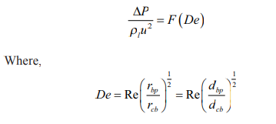 (9)
3.2 Friction Factor
The friction factor, f_{bp} for flow through a bend pipe is defined by the Fanning friction factor as
$f_{bp}=\frac{ⅆ_{p}ΔP_{bp}}{2u^{2}ρ_{l}L_{bp}}$ (10)
The following modified equation is used for bend pipe:
$f_{bp}=F(De_{bp}\text{)}$
The following functional relationship is used to extend the applicability of the Eq. 10 with an angle factor to all the different bends in the horizontal plane
$f_{bp}= F\left(De_{bp},\frac{α}{180}\right) (11)$
When bend angle α → 0, radius of curvature of the bend, r_{cb} will be closed to zero, i.e., bend becomes straight and the friction factor, f bp of Eq. 11 will be equal to the friction factor of the straight pipe, f _{s}. By incorporating the above limiting condition, Eq. (11) can be modified in the following manner:
$\frac{f_{bp}}{f_{x}}-1=F\left(De_{bp},\frac{α}{180}\right) (12)$

CHAPTER:4
4 CFD Analysis

4.1 Mathematical Model
Dilute solutions of SCMC behave as a time independent non-Newtonian pseudo plastic fluid. The fluid follows the laminar non-Newtonian pseudo plastic power law model. The k-ε model is used for water in bends in a turbulent region. The apparent or effective viscosity, µeff are defined from Power law model for non-Newtonian fluids as,
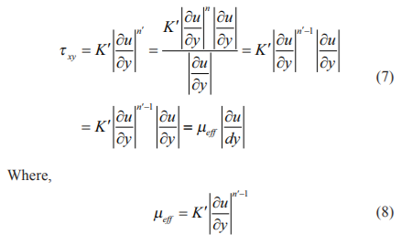
(9)

(10)
Where, K′ = consistency index and n′ = flow behaviour index. The flow behaviour index, n′ is an important parameter to subdivide the fluids as Newtonian (n′ = 1), pseudo plastic (n′< 1) and dilatants (n′ > 1). The deviation of n′ from unity indicates the degree of deviation from Newtonian behaviour and (n′ < 1) indicates the shear thinning behaviour of pseudo plastic fluids

4.2 Measurement of rheological properties
Rheological properties and density of the solutions were measured experimentally by pipeline Viscometer and by the specific gravity bottle. The rheological properties, consistency and flow behavior index are obtained from the intercept and slope of the log-log plot of wall shear stress (dbp ∆P / 4L) vs. shear rate (8ul / dbp). The basic relationship is developed by Metzner and Reed (1955) for power law fluid to relate pressure drop with the flow rate of SCMC solution by means of geometric parameters and the two physical properties of the fluid K′ and n′ as,
$\frac{ⅆ_{bp}ΔP}{4L}=k^{'}{\left(\frac{8u_{1}}{d_{bp}}\right)}^{n^{'}}$
Where,
$k^{'}=\frac{k\left(3n^{'}+1\right)}{4n^{'}}$
And
$n^{'}=\frac{ⅆ\left[\ln\left(d_{\frac{bp^{Δ}P}{4L}}\right)\right]}{ⅆ\left[\ln\left(\frac{8u}{d_{b_{P}}}\right)\right]}$

4.3 Governing equation
The effective viscosity is used for the calculation and defined as
$μ_{e_{ff}}=K^{'}{\left(\frac{8u_{1}}{d_{bp}}\right)}^{n^{'}-1}$
The governing continuity and momentum equations are the Navier-Stokes equation and can be written as, Continuity equation:
$∇u=0$
Where, u is the non-Newtonian, SCMC solution velocity. Momentum equation:
$ρ_{\frac{∂u}{∂_{t}}+pu_{∇}u}=u_{e_{ff}}∇_{u}^{2}-∇_{P}$
Where
$∇=ⅈ\frac{∂}{∂x}+j\frac{∂}{∂y}+k\frac{∂}{∂z}$
For steady non-Newtonian, SCMC solution flow, momentum equation is written as,
$u\frac{∂u}{∂x}+v\frac{∂v}{∂y}=\left(\frac{1}{ρ}\right)\frac{∂ζ_{xy}}{∂y}$
Where, u and v are the x and y velocity components respectively, τxy is the shear stress and ρ is the density of non-Newtonian pseudo plastic fluid (SCMC solution).

4.4 Boundary conditions
The continuity and momentum equations are solved subject to the following boundary conditions:
(a) Assuming bend walls are rigid and hence no slip conditions are introduced.
(b) Velocity is considered as inlet parameter and
(c) The outlet is the pressure of the fluid at the end of the pipe.

4.5 Assumptions of SCMC solution flow through bends
The following assumptions are taken for non-Newtonian pseudo plastic liquid flow through bends:
(a) The non-Newtonian pseudo plastic liquid flow through bends is 3-D fully developed and steady. For lowering the cost, we have used here fully developed i.e., the transition length of 50-80 ID for turbulent and laminar flow. The computer memory requirement was lowered during grid generation and simulation to minimize the convergence time.
(b) The fluid is isothermal, incompressible and non-Newtonian.
(c) The temperature of SCMC solution is fixed to 31°C.
(d) Single phase laminar pseudo plastic power law model is considered.
(e) Non-Newtonian pseudo plastic and Newtonian water flow through bend is complex in nature. Secondary flow appears inside the bend. It is governed by the conservation of mass and momentum equation with laminar and turbulent flow condition.

4.6 CFD procedure
Mesh Geometries for the bends are created by using CFD pre-processor. The inlet is used to specify the inlet velocity and outlet is used to specify the pressure outlet. The mesh geometries of the bends are imported into CFD solver in 3-D, X, Y, Z Cartesian co-ordinate system. The pressure based CFD solver solved the governing equations in 3-D geometry. Laminar non-Newtonian Power Law model has been used for simulation. The model solves the Navier-stokes equation at prescribes velocities. The governing equations are nonlinear and several iterations of the loop must be performed before a convergent solution is obtained. The first-order upwind scheme is used in the discretization of a set of governing equations and interpolation schemes are used for calculating cell-face pressures using the segregated solver. Pressure-velocity coupling refers to the numerical algorithm which uses a combination of continuity and momentum equations to derive an equation for pressure (or pressure correction) while using the segregated solver. A Simple algorithm is used in CFD solver domains. The convergence criteria were set at 10-5 for momentum and 10-3 for continuity equation. The CFD based CGS solver is used for velocity and AMG solver is used for pressure correction.

CHAPTER:5
5 Results and discussions
5.1 Numerical simulation
The CFD based software is used to numerically simulate the non-Newtonian pseudo plastic liquid flow through bends. Different geometries of bends are created depending on angle and mesh by using the CFD module. Unstructured grids with tetrahedral elements are used for generating meshes. A grid independence study was carried out by varying the number of elements in the bend domain. Grid having 17055-44000 elements with varying bend angles is found to be sufficient as any further refinement does not produce any change in velocity and pressure profiles at various cross sections. Velocities corresponding to Reynolds number ranging from 200 to 3000 are used in the simulation for non-Newtonian pseudo plastic liquid flow through bends. The first order upwind scheme is used for calculation. A 3-D flow simulation over the entire length of the angular bends has been studied. The effect of various parameters: bend angle, flow rate or velocity on viscosity, static pressure, pressure drop has been discussed below

5.2 90 Degree Bend Pipe
Radius pipe =10mm
Bend radius=15mm
u= 500mm
V=200mm
Element size=0.0005 m
Behavior=
Viscous model =k omega model
Option = SST production limiter
SCMC= C8H16NaO8
Molecular weight =263.20
Density=0.5=0.7 g/cm^3
= (0.3=0.7 10^=3/10^=6) kg/m^3
= 500=700 kg/m^3
Temperature = 25 c
Viscosity = 1500=3000 centipoise
= 1.5=3 kg/ms
Velocity=6m/s
Turbulence
Specification method: intensity and viscosity ratio
Turbulent intensity= 5%
Turbulent viscosity ratio = 10
Viscosity specification method: magnitude, normal boundary
Change in mass flow rate

Solution methods
- Scheme = simple
- Spatial discretization
- Gradient= green gauss cell based
- Pressure = second order
- Momentum= second order upwind
- Turbulent kinetic energy= second order upwind
- Specific dissipation ratio= second order upwind
Monitors:
Residual
Continuity
X= velocity
Y=velocity
Z= velocity
K=eption
Iterations = 50
Plots :
Y=static pressure (pa)
X= position (m)

Cumulative plots:
Y = cummulative force
X= distance (m)

History of static pressure:
Surface integrals
Static pressure(outlet) = - 1.39 3je+ 33
Inlet =
Velocity at inlet =6m/s
Velocity at outlet = 0.0001921141 m/s
Roughness constant = 0.5
Wall motion=stationery
Shear condition=no slip
Roughness model= standard
Area inlet= 0.0156598 m^2
Absolute mass flow average of pressure on inlet = 1.88065e +10 (pa)
Scaled residuals
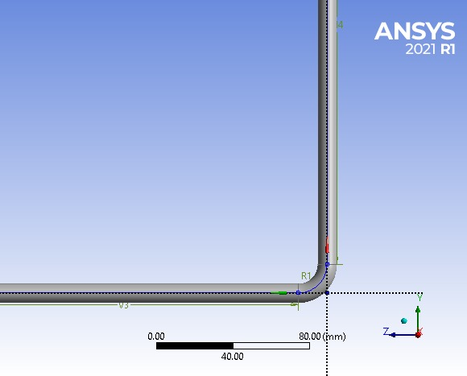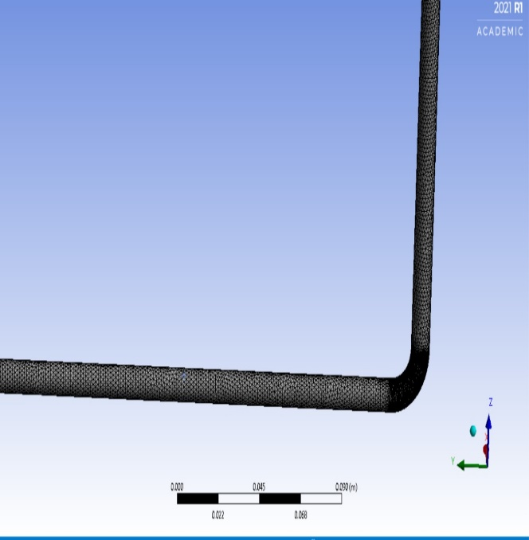
- (b)

Fig 6: (a) Geometry, (b) Mesh Design For 90 Degree Bend

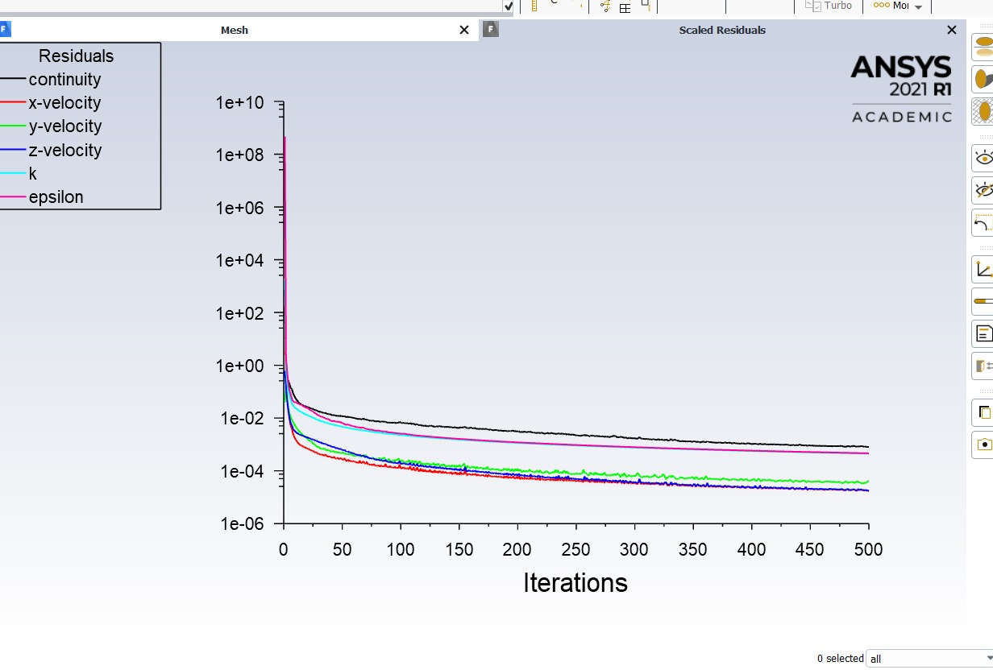

Fig 7: Scaled Residuals V/S Iteration for 90 Degree Bend

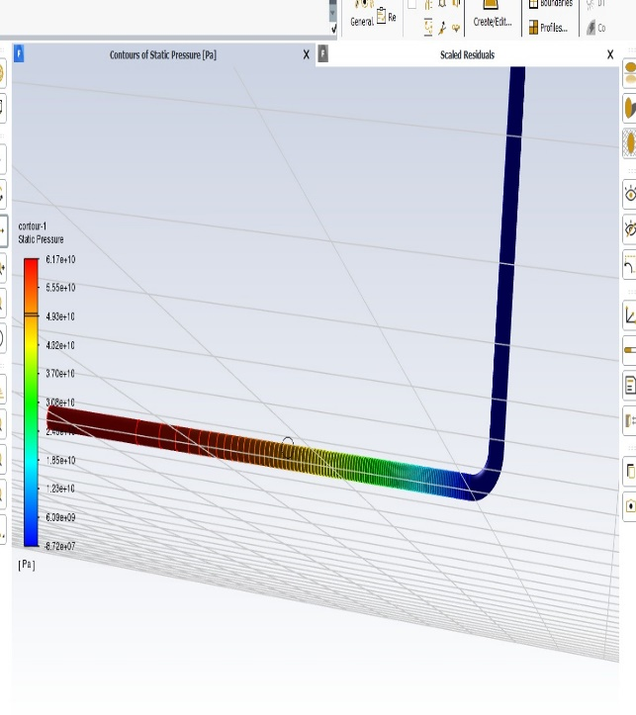

Fig 8: Static Pressure Contour for 90 Degree Bend

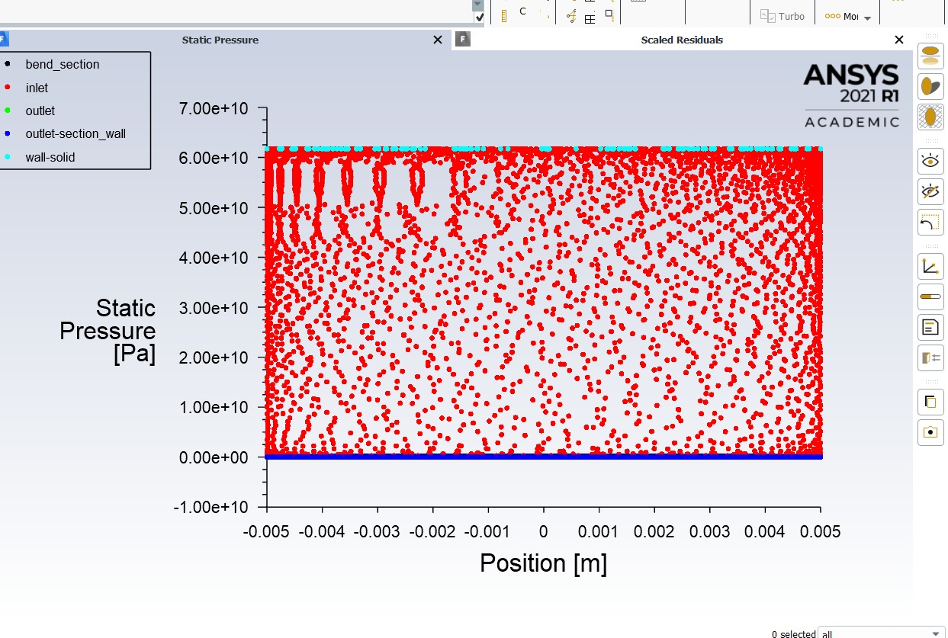

Fig 9: Static Pressure V/S Position Graph for 90 Degree Bend

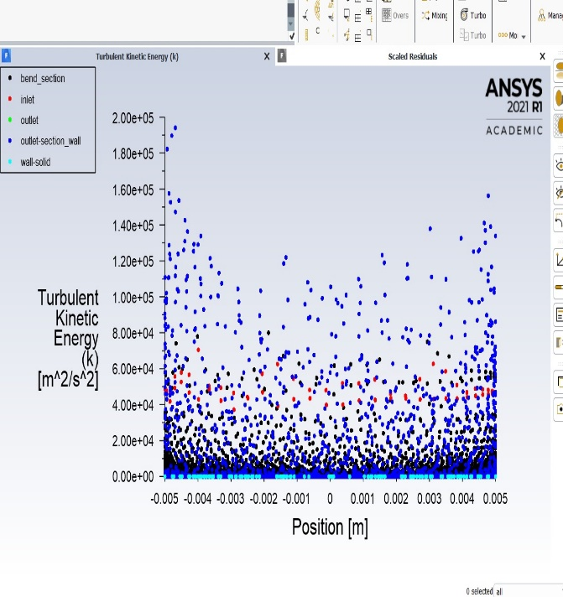

Fig 10: Turbulent Kinetic Energy V/S Position for 90 Degree Bend

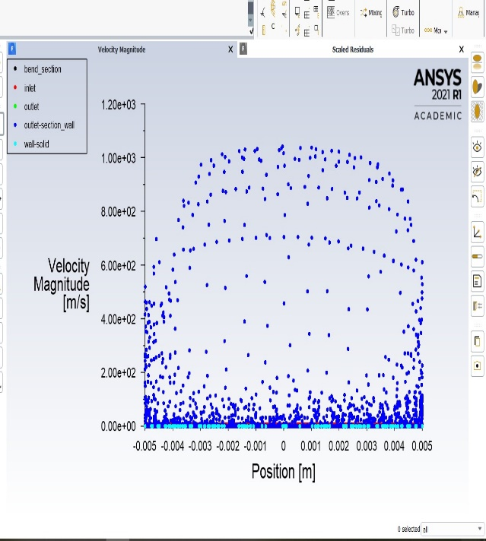

Fig 11:Velocity V/S Position Graph

5.2 U TUBE BEND PIPE
diameter of pipe=
length of pipe= 250 mm

transform=offset global x
mirror=
volume of complete body= 2.8045e+0.6 mm^3
surface area of complete body = 2.2829e+0.5 mm^2

Meshed Pipe
element order= linear
physicx preference =CFD

Setup
gravity =9.8
viscous laminar
fluid= sodium carboxymethyl cellulose
density= 500 kg/m^3
viscosity= 1.5 kg/ms

material of pipe= aluminium
density= 2719 kg/m^3

velocity inlet =5m/s

Pipe wall
stationery wall
shear condition = no slip
wall roughness constant= 0.5

Solution Method
pressure velocity coupling
scheme= simple

spatial discretization
gradient= green gauss cell based
pressure = second order
momentum= second order upwind

residual monitors
convergence criteria= absolute

Figures
# counters of static pressure
#static pressure vs position(m)
#Velocity magnitude vs position(m)
#Mass imbalance(kg/s) vs position(m)
#Scaled residual vs iterations

REPORT TYPE
pressure at inlet=152951.4
pressure at outlet=0
pressure at pipe wall = 74385.95 pa

#Pressure contour -1
#Velocity contour-2
#Pressure gradient -contour
#Velocity streamline contour

velocity vector-1
sampling= vertex
reduction =reduction factor
variable =velocity
connectivity number
min=2
max=10
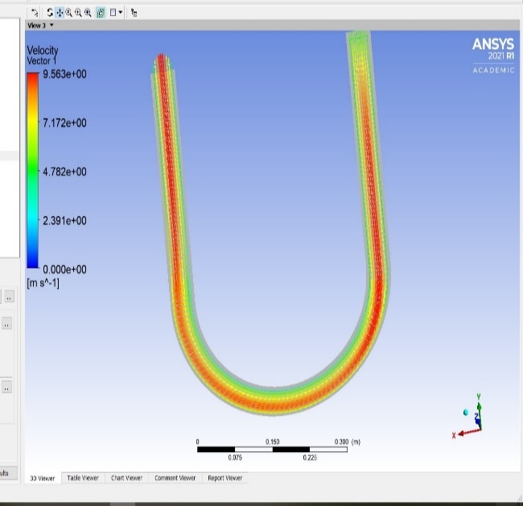

Fig 12: Velocity Vector for U Turn Bend

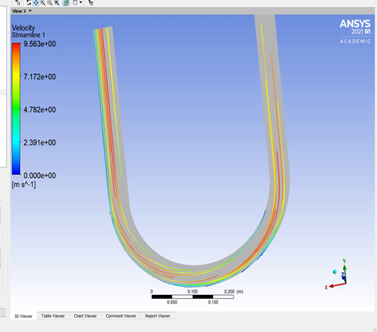

Fig 13:Velocity Streamline for U Turn Bend

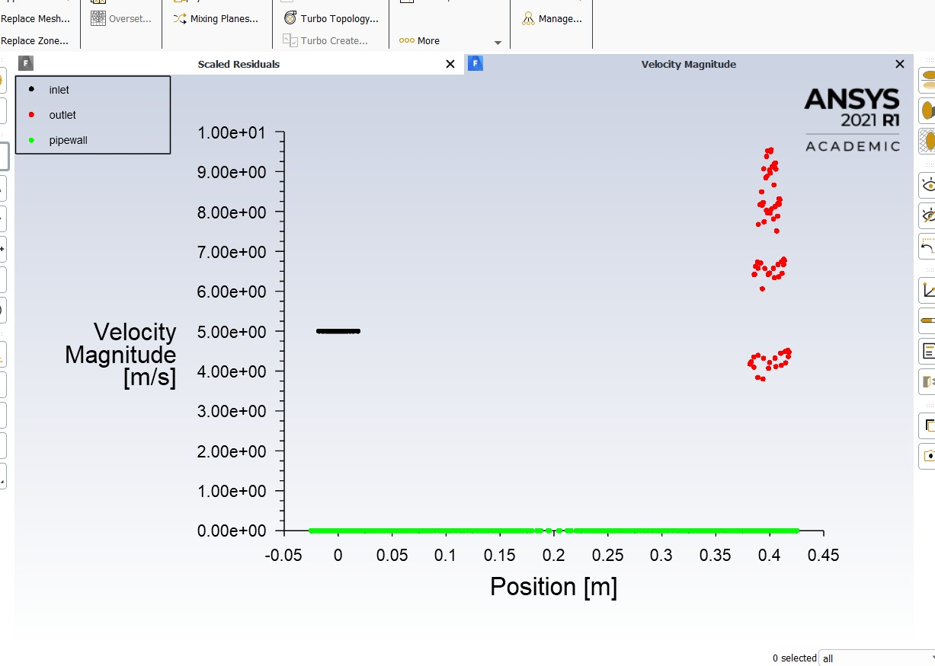

Fig 14: Velocity Magnitude V/S Position for U Turn Bend

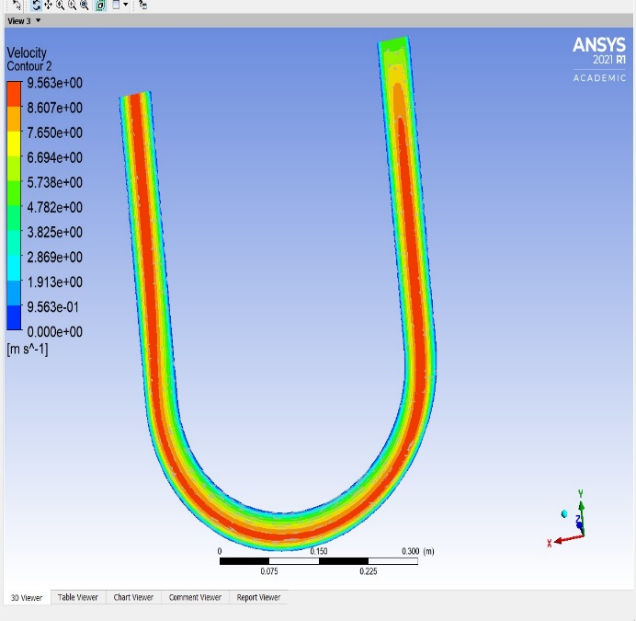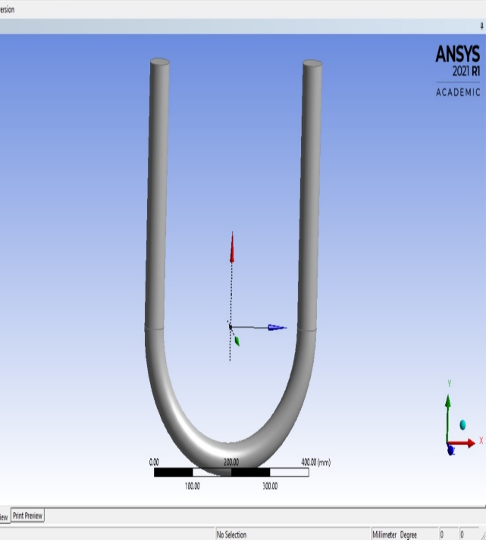
- (b)

Fig 15: (a)Velocity Contour, (b) Geometry For U Turn Bend
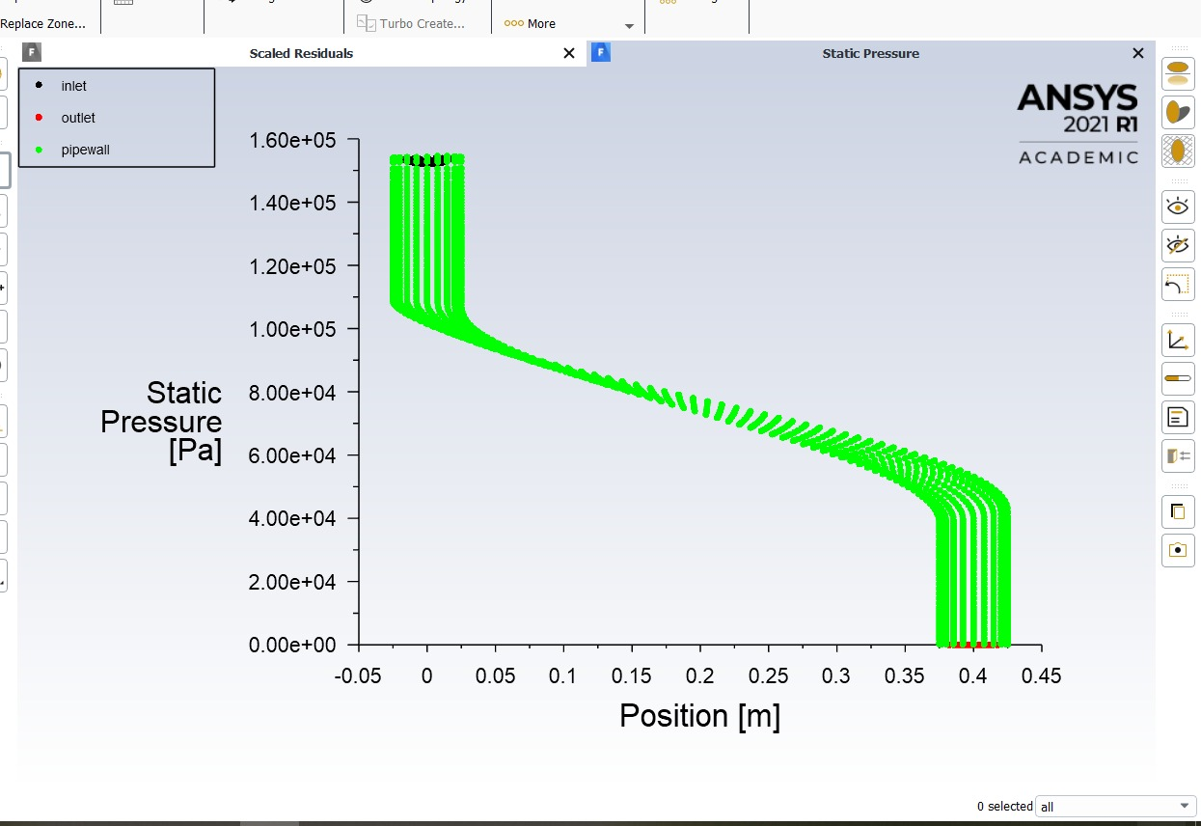

Fig 16: Static Pressure V/S Position

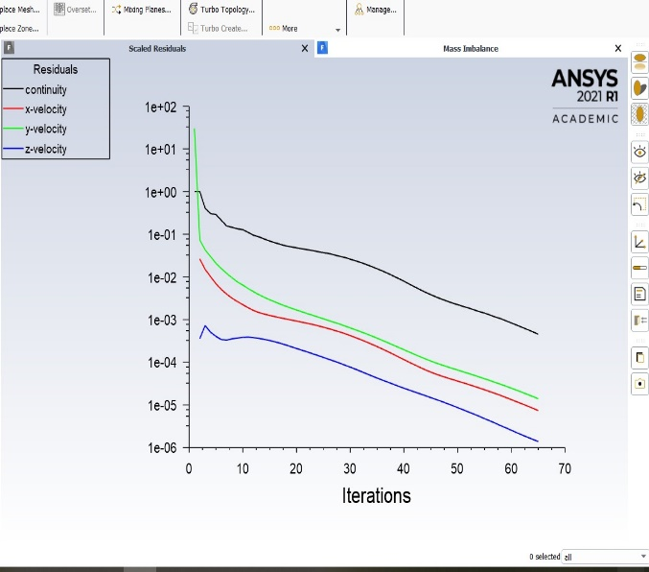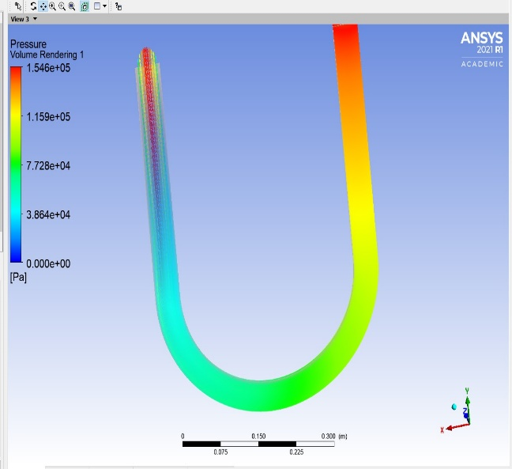
- (b)

Fig 17:(a)Scaled Residual V/S Position,(b) Pressure Volume Rendering

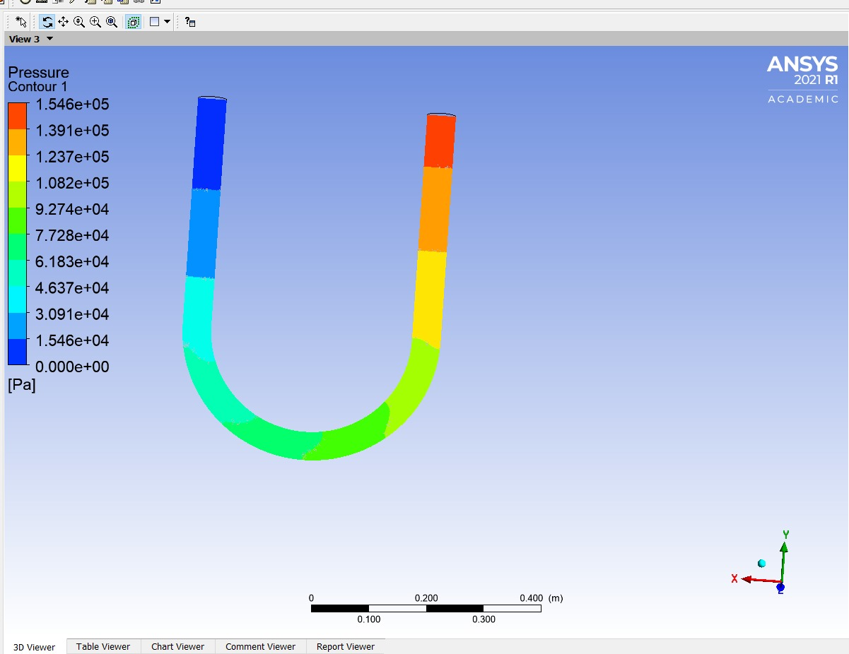

Fig 18: Pressure Contour for U Bend

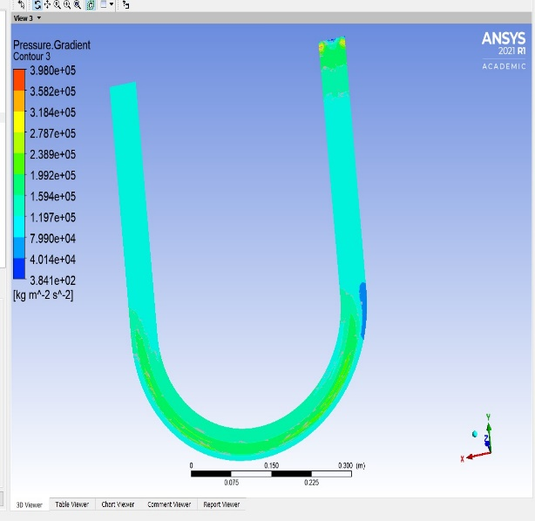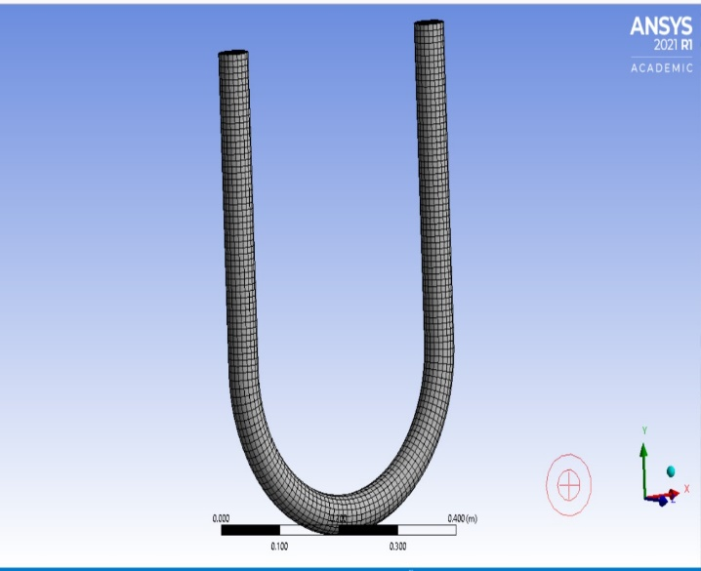
- (b)

Fig 19: (a) Pressure gradient contour 3, (b) Mesh design for U bend

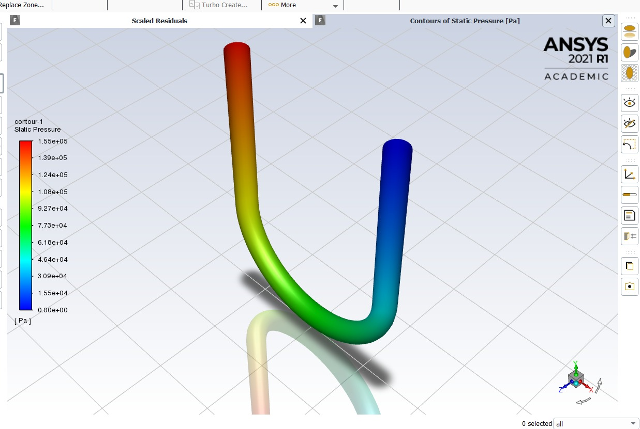

Fig20:Contour 1 Static pressure for U bend pipe

5.4 DISSCUSSION
5.4.1 Effect of bend angle on single-phase pressure drop
Fig. 8 and Fig. 20 show the effect of bend angle on static pressure. It is clear from the plot that as the bend angle increases, the single-phase pressure drop decreases SCMC. The reason is that as the magnitude of the secondary flow and the centrifugal forces acting on the liquids are reduced with increasing bend angle and hence the single-phase pressure drop decreases. The increase of bend angle means low curve and large radius of curvature and hence more closer to behave as a straight pipe which can reduce the centrifugal and secondary forces on the fluid inside the bends and hence reduced the kinetic energy loss.
5.4.2 Effect of bend angle on velocity magnitude, velocity vector
Fig. 5 (a) – (e), Fig. 6 (a) – (f), Fig. 7 (a) – (f) indicate the contour plot of velocity magnitude, velocity vector and dean vortices. From those plots, we observe that the intensities of velocity magnitude, velocity vector are diminished. This is due to the increase of bend angle, which lowers the intensities of secondary flow phenomena and hence reduce the centrifugal forces on the fluid inside the bend. The centrifugal force is, in principle, balanced by the pressure gradient in the plane of curvature. However, near the wall where the velocity is small, the pressure gradient can no longer be balanced and consequently fluid in the middle of the pipe moves to the outer wall and then turns to move inwards along the wall. The flow on the outer wall and separation at the inner wall make the flow very complex. The increase in bend angle,a lowers the magnitude of Dean Number of bend, De_{b} = Re (r_{bp}/r_{cb}) 1/2 = Re (d_{bp}/d_{cb})½ and hence lower the curvature effect value of (d_{bp}/d_{cb})½. In this case the curved bend behaves like a straight pipe where the radius of curvature will be a → 0 or dcb → ∞ and hence Re is important than De to lower the intensity of Dean Vortices.
5.4.3 Effect of bend angle on cell Reynolds number and dynamic pressure
Fig. 9 (a) – (e), Fig. 10 (a) – (e), illustrate the contour plot of cell Reynolds number, dynamic pressure . All are decreased with as increase in the bend angle. This is due to the decreasing of centrifugal forces.
5.4.4 Effect of bend angle on wall shear stress and strain rates
Fig. 12 (a) – (f) and Fig. 13 (a) – (f) show the contour plot of wall shear stress and strain rates which are decreasing with increasing bend angle. The effects are less pronounced with increasing bend angle as the magnitude of τrɵ components are decreased with angle and thus the magnitude of low angular velocity (ω) lowers the values of shear stress and strain rate. The shear stress and strain are relatively more near the wall side compared to the central position of the pipe bend as the velocity variation between the fluid layers is more near the wall side compare to the central position

Chapter 6
6.1 CONCLUSION

REFERENCES
References [1] Dean, W. R. "Fluid motion in a curved channel." Proceedings of the Royal Society of London. Series A, Containing Papers of a Mathematical and Physical Character. 121(787), pp. 402-420. 1928. https://doi.org/10.1098/rspa.1928.0205
[2] Dean, W. R. "The Stream-line motion in curved pipes." The London, Edinburgh, and Dublin Philosophical Magazine and Journal of Science. 5(31), pp. 673-693. 1928. https://doi.org/10.1080/14786440408564513
[3] Berger, S. A., Talbot, A., Yao, L. S. "Flow in Curved Pipes." Annual Review of Fluid Mechanics. 15, pp. 461-512. 1983. https://doi.org/10.1146/annurev.fl.15.010183.002333
[4] Soh, W., Berger, S. A. "Laminar entrance flow in a curved pipe." Journal of Fluid Mechanics. 148, pp. 1984. https://doi.org/10.1017/S0022112084002275
[5] Das, S. K., Biswas, M. N., Mitra, A. K. "Friction factor for gas-nonnewtonian liquid flow in horizontal bends." The Canadian Journal of Chemical Engineering. 69(1), pp. 179-187. 1991. https://doi.org/10.1002/cjce.5450690121
[6] Mashelkar, R. A., Devarajan, G. V. " Secondary flows of non-Newtonian fluids: Part I – laminar boundary layer flow of a generalized non-Newtonian fluid in a coiled tube." Transactions of the Institution of Chemical Engineers. 54, pp. 100-107. 1976.
[7] Mishra, P., Gupta, N. "Momentum transfer in curved pipes. 2. Non-Newtonian fluids." Industrial & Engineering Chemistry Process Design and Development. 18(1), pp. 137-142. 1979.
[8] Edwards, M. F., Jadallah, M. S. M., Smith, R. "Head losses in pipe fittings at low Reynolds numbers." Chemical Engineering Research and Design. 63, pp. 43–50. 1985.
[9] Bandyopadhyay, T. K., Das, S. K. "Non-Newtonian pseudo plastic liquid flow through small diameter piping components." Journal of Petroleum Science and Engineering. 55(1-2), pp. 156-166. 2007. https://doi.org/10.1016/j.petrol.2006.04.006
[10] Bandyopadhyay, T. K., Das, S. K. "Non-Newtonian and Gas-non-Newtonian Liquid Flow through Elbows – CFD Analysis." Journal of Applied Fluid Mechanics. 6(1), pp. 131-141. 2013. URL: http://www.sid.ir/en/ VEWSSID/J_pdf/112520130115.pdf
[11] Hidayat, M., Rasmuson, A. "Numerical investigation of gas-solid flow in a U-bend." In: Proceedings of the 13th International Drying Symposium., Bejing, China, pp. 424-433. 2002.
[12] Marn, J., Ternik, P. "Laminar flow of a shear-thickening fluid in a 90° pipe bend." Fluid Dynamics Research. 38(5), pp. 295-312. 2006. https://doi.org/10.1016/j.fluiddyn.2006.01.003
[13] Kuan, B., Yang, W., Solnordal, C. "CFD simulation and experimental validation of dilute particulate turbulent flows in a 90o duct bend." In: Third International Conference on CFD in the Minerals and Process Industries. CSIRO, Melbourne, Australia, Dec. 10-12, 2003. pp. 531-536. URL: http://www.cfd.com.au/cfd_conf03/papers/084Kua.pdf
[14] Shah, S. N., Jain, S. "Coiled tubing erosion during hydraulic fracturing slurry flow." Wear. 264(3-4), pp. 279-290. 2008. https://doi.org/10.1016/j.wear.2007.03.016
[15] Wu, B., Chen, S. "CFD simulation of non-Newtonian fluid flow in anaerobic digesters." Biotechnology and Bioengineering. 99(3), pp. 700-711. https://doi.org/10.1002/bit.21613

